1. **List all employee names with their project name**

SELECT employee.ename, projects.Pname

FROM employee, projects, work_in

where employee.eno = work_in.eno and work_in.Pno = projects.Pno

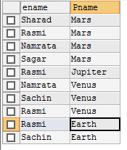

1. **List name of all employee and their salary who are working in project “Mars” or “Venus”**

SELECT employee.Ename, employee.Salary

FROM employee

INNER JOIN projects

ON employee.DepNo=projects.DepNo

where projects.PName="Mars" OR projects.PName="venus";

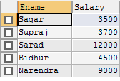

1. **List name of all employee and salary who are working in project earth and venus**

SELECT employee.Ename, employee.Salary

FROM employee

INNER JOIN projects

ON employee.DepNo=projects.DepNo

where projects.PName="Earth" AND projects.PName="venus";



1. **List name and address of all employees who works in department which is located in pokhara**

SELECT employee.ename, employee.address

FROM employee, department

where employee.dep_no= department.dep_no and department.Location="pokhara"

